Peoria Police Department
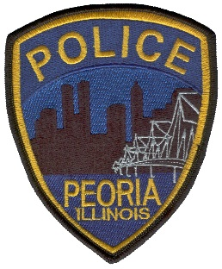

To: ILETSB, IL GOVERNORS OFFICE, IL GENERAL ASSEMBLY
From: Jack Nieukirk, Police Technology Administrator
Date: Friday, May 15, 2020
Subject: In-Car Camera Grant FY19 Report
To Whom it may Concern,
Please find and accept the attached documents as the City of Peoria Police Department’s In-Car Camera Grant FY19 Report. Enclosed you will find a roster of In-Car Cameras purchased with Grant Funds showing their dates of installation, a brief description of the review process for in-car video by supervisors, and the camera report for where in-car video was used in prosecution.
This report was delayed in delivery to your offices due to an oversight by department personnel and my office not being aware of the report requirements. Following notification of the reporting requirements, our staff worked diligently to collect the data required and resulted in this delay. Future years reports will not be delayed as we are putting protocols in place to ensure data collection throughout the year and preparation of reports prior to the due date.
Should you have any questions, please do not hesitate to contact me.

Respectfully Submitted,

Jack Nieukirk
Police Technology Administrator
Peoria Police Department
(309) 494-8309
jnieukirk@peoriagov.org

