June 23, 2022

The Honorable JB Pritzker
Governor
207 State House
Springfield, IL 62706

Dear Governor Pritzker:

Please see the enclosed report from the State Treasurer’s Office pursuant to Public Act 99-370. This report contains the results from the review of our rules, administrative regulations, and permitting processes as they pertain to small businesses. Generally, the State Treasurer’s Office has been working to reduce or eliminate processes that are unreasonable, unduly burdensome, duplicative, or onerous to small businesses in our administrative procedures through amendments to our administrative rules and application processes. My office will continue these efforts to become more efficient and better serve the small businesses that use our programs.

Sincerely,

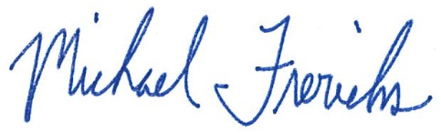

Michael Frerichs
Treasurer

