FOSTER YOUTH SUMMER INTERNSHIP PILOT PROGRAM
YEAR ONE AND TWO

Year One
Summary Report

Public Act 099-0285, Section 5 (20 ILCD 505/8.1) became effective August 8, 2015. This act amended the Children and Family Services Act to implement a Foster Youth Summer Internship Pilot Program for the purpose of providing foster youth with professional training and experience through internships. The implementation of the Public Act began January 1, 2016.
The purpose of the pilot program is to provide our youth in care with the employment experience needed to further their development in becoming successful adults.
At the end of this two year pilot period, the internship/employment program is to have developed rules for the Foster Youth Summer Internship Pilot Program, implement internships over the two year period, and submit a final report to the General Assembly of the Department of Children and Family Services findings. The report is to include, but not limited to, the number of youth participate in the pilot, the locations along with the types of internships provided, and the Department’s efforts to recruit individuals to participate in the pilot.
Beginning Stages
Members of the Illinois Department of Children and Family Services (DCFS) Management Team (Mike Ruppe and Tammy Grant) were assigned to address the implementation of the Public Act. After their meeting, additional members and designees were added to identify a committee for this pilot. The committee consisted of representatives from various DCFS divisions from the following areas: Operations, Office of Learning and Professional Development (OLPD), Legal, Office of the Guardian, Office of Child Well Being/Education and Transition, Office of Employee Services/Selection and Recruitment (OES) and the Office of Strategic Planning and Innovation. The Initial Committee Members identified were: Debra Dyer Webster, Tammy Grant, Diane Cottrell, Lisa Spacapan, Tiffany Gholson, Joyce Bryan, April Curtis and Mike Ruppe.
At the first meeting, the Initial Committee was provided with job descriptions and a copy of the Public Act. The discussion from this first meeting resulted in needing time to review job descriptions, the Public Act and identify similar programs which might already exist, especially in private agencies already working with DCFS. It was made clear the implementation of the program belonged to the entire committee and not to one specific person or one division was to assume leadership over the others. The members of the Large Committee were identified as the following: Debra Dyer-Webster, Tammy Grant, Diane Cottrell, Lisa Spacapan, Tiffany Gholson, Joyce Bryan, April Curtis, Mike Ruppe, Lynda Swan-McClendon, Geny Chiaradonna, Toccara Steele, Lori Gray; Catherine Smith, Desiree Silva, Jacqui Colyer, Jody Grutza, Erica Kirkwood, Monico Whittington-Eskridge and Maria Miller.
By mid-March 2016, the Large Committee was coming together with ideas and items which needed to be addressed in order to successfully implement the program. A few of the divisions took the initiative and identified items for the pilot consideration. OES was working with Director’s office to identify a stipend, along with CMS in clarifying job descriptions and posting language, with the Office of the Guardian to address the conducting of background checks. The Office of the Guardian and Education Transition prepared an outline for identifying and reaching the target population. They were able to provide a template program plan currently used by Kaleidoscope.
During the Large Committee’s second meeting, materials and opinions/thoughts were reviewed and discussed. There was a general consensus this was an exciting pilot and offered a wonderful opportunity for our youth in care. After this meeting, it was apparent not all divisions had the time or resources to be able to commit to the implementation of the pilot. In addition, there was some discussion as to which regions should house the interns and the number of interns to be included. There were some desiring a statewide program of at least 20 interns, while others concluded they didn’t want the pilot to be conducted in Cook County. In addition, there were others which felt the pilot should begin with a small number of interns the first year with the plan to increase the number of interns in the second year.
Below, are the terms we agreed upon as pilot parameters for Year One:
- Conduct the test pilot prior to adopting rule;
- The applicants considered for employment were to come from the DCFS Youth Advisory Board (YAB);
- Youth in care were not to be placed in field offices or work in areas where they had contacts with case workers, youth in care or families /foster parents of youth in care;
- Field offices facing issues were not to be used for pilots;
- DCFS would not utilize a private agency to run the internship program or house the internships;
- Would include the high school population and not limit the pilot to college students;
- and the work group would be responsible for preparing a work plan implementing the ideas voiced during the meetings and by committee members.
Members from the Large Committee volunteered to form the Work Group for this pilot. The group scheduled meetings to begin preparing to create the work plan. The members of the Work Group identified were: Joyce Bryan (Office of Learning and Professional Development), Monico Whittington- Eskridge (Office of Learning and Professional Development) to replace Joyce after she retired, Toccara Steele (Office of Learning and Professional Development); April Curtis (Strategic Planning and Innovation/Director's Office), and Geny Chiaradonna (Office of Employee Services).
Development of the Work Plan
The Work Group met and took into consideration the opinions/thoughts of the Large Committee. The Large Committee was sent the work plan (see attachment) and given two weeks to review. The Work Group received several positive comments regarding the plan. The Work Group also met with Regional Administrators to gauge interest and support in hiring youth and young adults in their sites, all regions were responsive and supportive.
At the next meeting, the Year One Work Plan was reviewed and commented upon. The Work Group provided responses and agreed to incorporate the comments and suggestions made by Large Committee. In addition to the work plan, the Work Group addressed the finalization of the number of interns/locations, identification of possible work units to host interns, changes the clarification needed to the Student Worker Job Description, posting requirements, timelines and work assignments; and agreed the youth recruited for the pilot were to be active members of the Youth Advisory Board (YAB).
In spite of limited time frames, the Work Group accepted the roles and went on to implement the Year One plan. Due to the Office of Learning and Professional Development’s work with DCFS Academic Internship Program as Toccara Steele being the Director, this office was designated as the natural point unit to identify, establish and maintain the data for all reports, including the final report to the General Assembly at the end of the two year pilot.
In addition to the members of the Work Group listed above, Jason Sage (Office of Learning and Professional Development) and Lynda Swan-McClendon (Office of Education and Transitional Services) were added to the group. Jason Sage was in charge of collecting and analyzing data. And, due to Lynda Swan-McClendon’s assistance in working directly with the YAB youth and ability to identify youth eligibility this was the role she played within the Work Group.
Year One of the Internship Pilot would be a four week program, with up to 3 interns (Student Workers) in each region, not to exceed twelve interns. The work locations were to be in cities with reliable public transportation system. The cities identified for Year One were: Chicago, Springfield, Champaign, Aurora, and East St. Louis.
The youth in care had to be at least 16 years old due to the need of a work permit. The interns would be hired into Student Worker titles. The Student Worker positions would be posted in accordance to Personnel Rules. Rutan Interviews would be conducted. All interns within in youth pilot program would be paid the Student Worker rate identified for Cook County.
The learning objectives identified were: punctuality; appropriate attire; how to interact with colleagues; phone etiquette; learning about various divisions within DCFS; usage of computers and copiers along with other office equipment as needed.
Preparation for Program Implementation
The Work Group enthusiastically embraced working on the various components necessary to implement this new program within a short time frame. The Work Group met on an average of weekly to biweekly to discuss the progress of various assignments, to address issues or concerns which would arise.
During the preparation period duties for implementation were divvied up amongst the members of the Work Group. The Office of Employee Services worked on clarifying the Student Worker Job Description, worked with CMS to limit eligibility to YAB in posting notices, prepared interview questions, identified interview panels, addressed payment procedures with Payroll, and kept the designated student worker supervisors informed of progress, with the assistance of the Office of Learning and Professional Development. In addition, the Office of Employee Services and the Office of Learning and Professional Development kept the work group updated and responded to general inquiries regarding the program. The Office of Learning and Professional Development with the Office of Employee Services worked on identifying the possible locations for internships. The Office of Professional Development was solely responsible for the development of both pre and post surveys by the interns. Evaluations which were to be completed by supervisors of the interns in the pilot were developed and distributed by Office of Employee Services. At the request of Lori Gray, Mt Vernon was added as site, even though there were some concerns about available public transportation. April Curtis worked in partnership with the YAB Staff disseminating information to YAB and addressing questions regarding progress of the Work Group. Toccara Steele created the agendas for the Lunch and Learn Sessions. Jason Sage assumed the role of developing and maintaining data for all reporting, which includes the final report.
The Office of Employee Services was able to identify the posting periods of the Student Worker positions, interview dates, and start dates for the interns and provide the Work Group a sample of application identifying the key areas to be completed when applying for the internship. April Curtis shared this information with key people involved within YAB so they would be prepared to respond to posting notices.
Posting notices for the student worker pilot were posted to CMS employment website on May 25, 2016 for a 10 day period. Using social media, April assisted in sending out information regarding posting notices. Both April Curtis and Lynda Swan McClendon addressed questions from private agencies regarding the posting notices and from YAB.
After the positions were posted, the Work Group received questions and concerns from the YAB concerning such topics as age and schooling requirements, background record questions, and deadline to apply, for example. The Work Group was able to address each of the concerns and made accommodations that still complied with personnel rules and protocols.
Summary of the Response to Posting
For year one of the pilot, twenty-one applications were received. Six applicants were interviewed and chosen.
Wrap Up: Summary of Year One and Outcomes
This was a positive experience for the youth, supervisors and the Department. Toccara Steele conducted the weekly Lunch and Learn Sessions which were successful via telephone conference lasting no longer than an hour. It was during these calls where the youth were able to share their experiences on a weekly basis. Also, they were given tools and resources needed to further them along into adulthood and the world as a whole. There were guest speakers to provide practical tools to review. The success of the sessions was being incorporated into the some of the regular activities of the YAB. Each youth intern was presented with Certificate of Participation and the participating supervisors received a Certificate of Thanks.
The supervisor's comments from the evaluation have been positive with indication they would be happy to participate in the second year of pilot. The most negative comment was concerning the time frame of the Year One pilot. Also, it was shared it would be great if more time was allotted for the year two of the pilot. Several of the supervisors have requested if their intern could remain as student worker or return during holiday breaks and next summer. We are pleased to note one of the interns has already had been able to extend the student worker title for an additional 5 weeks.
The Work Group also felt the first phase was a positive experience in spite of some minor obstacles faced. The first phase was implemented within the designated timeframes. It was the goal to provide an overall positive experience for our youth and the agency. There many times when supervisors had to speak to the youth about the importance of being on time, customer services as well as hygiene.
Further Recommendations
The Work Group believes this is a positive pilot program, and with the work which has already done can easily be incorporated into a full-time program with internships throughout the year. There are many challenges which would need to be addressed to make this program successful.
This Internship Program for Year Two should continue to be led by the members of the Work Group; at the end of Year Two a recommendation for the pilot would be need to be made. This small work group is comprised of members from the following divisions: OES, OETS, OLPD, and OSPI (Director’s Office).
It is best for the program to run at least four to six weeks. Adding another week or two could be close to the time when students will be preparing to go back to school. Due to the short amount of time given to prepare for Year One, the Work Group chose to host the pilot as a 4 week program. In addition, the Work Group desires more time to make this pilot very successful.

DCFS Youth Internship Year One Program Plan
*Please note: This plan was altered and changed accordingly to fit the needs of the Year One Pilot
Plan of Action Developed by the Work Group
Qualifying Criteria for Applicants:
- Illinois youth in care between the ages of 16 and 18
- Currently enrolled in high school, to include children in alternative schools or those being home schooled
- Must be an active member of the DCFS Youth Advisory Board
Important Dates for the Program:
Pre Kick Off Webinar with Licensing Workers: (time and date to be determined)
- Licensing workers were encouraged to be a supporting factor for youth chosen for the program.
- Program Announcement placed on DCFS Website
- Posting of Student Worker Vacancies
Kickoff: Friday, July 8, 2016
- Interns will be properly introduced to the Department
- Completing paperwork, required rules and policies, etc.
- Overview of what the interns can expect within the program
- Guest speaker on job readiness

Dates and Times of Instruction for the Program:
The interns were expected to work from 8:30 a.m. to 5:00 p.m., Monday through Friday.
- Week 1: Monday, July 11 through Friday, July 15, 2016
- Week 2: Monday, July 18 through Friday, July 22, 2016
- Week 3: Monday, July 25 through Friday, July 29, 2016
- Week 4: Monday, August 1 through Friday, August 5, 2016

- Interns were required to attend “Lunch and Learn” sessions each Friday from 1:00 p.m. to 2:00 p.m. Guest speakers will present on job skills via webinar.
- Interns were debriefed regarding how the objectives learned the previous week were applied.
- We identified objectives for the following week.

Application/Selection Process:
- Number of Selected Applicants for Year 1: 8 to 12 Interns
- Selecting eight interns will allow for each region to have two interns per region.
- Up to sixteen candidates may be interviewed, for no more than 12 internships.
- A smaller population of applicants will allow for a “Mentor-Mentee” model for Year 1.
- Data will be maintained during and after the intern’s experience.

Proposed Sites for the Selection and Placement Process for Year 1:
Aurora, Bloomington, Champaign-Urbana, East Saint Louis, Peoria, and Springfield
The selection of these cities was based on the population of members within the DCFS Youth Advisory Board.
Recommendation: Another city within the Northern Region (possibly Joliet) may be considered other than Aurora. The Academic Internship Program uses the Aurora office for the placement of many interns due to number of applicants placed from Aurora University.
These are cities with a sufficient public transportation system which would provide interns with efficient transportation to and from their assigned placement.

The Scheduling and Selection of the Interview Committee for Rutan Interviews:
- Upon receiving and selecting candidates for the positions, interview site(s) were identified.
- Rutan Certified Interviewers conducted the interviews.
- Interviews to begin being conducted first part of June.

Creation and Alterations of CMS Job Posting:
The Department anticipates having the position posted as early as the first week of May.
OES will be in charge of the following:
OES will arrange the pay schedule; Paperwork and Additional Department Documents.

Possible Placement Assignments:
The Office of Learning and Professional Development; Office of Employee Services; Office of the Guardian; OITS; Mailroom; Inventory Department; Communication; Clinical Division; The Office of Education and Transition Services
Learning Objectives:
The Department will be developing objectives for the interns to gain in alignment with the Public Act 099-0285 stating “Interns are to receive professional training and experience.”
Some skill sets we are looking to project are the following but are not limited to
Flexibility; Communication; Conflict Resolution; Workplace etiquette, attire, and practices; Money Management
Evaluation Tools:
The Department developed a strategy to capture the experiences from a pre and post perspective from both the intern and the supervisor. A survey using closed ended questions will be completed to provide information for reports prior to and after Year Two of the pilot. Gaining this information will allowed for us to collect data which will later be compared to Year Two of the program. We are looking to use the same tools for Year Two of this pilot.

Pictures of the Interns from the Year One Pilot:

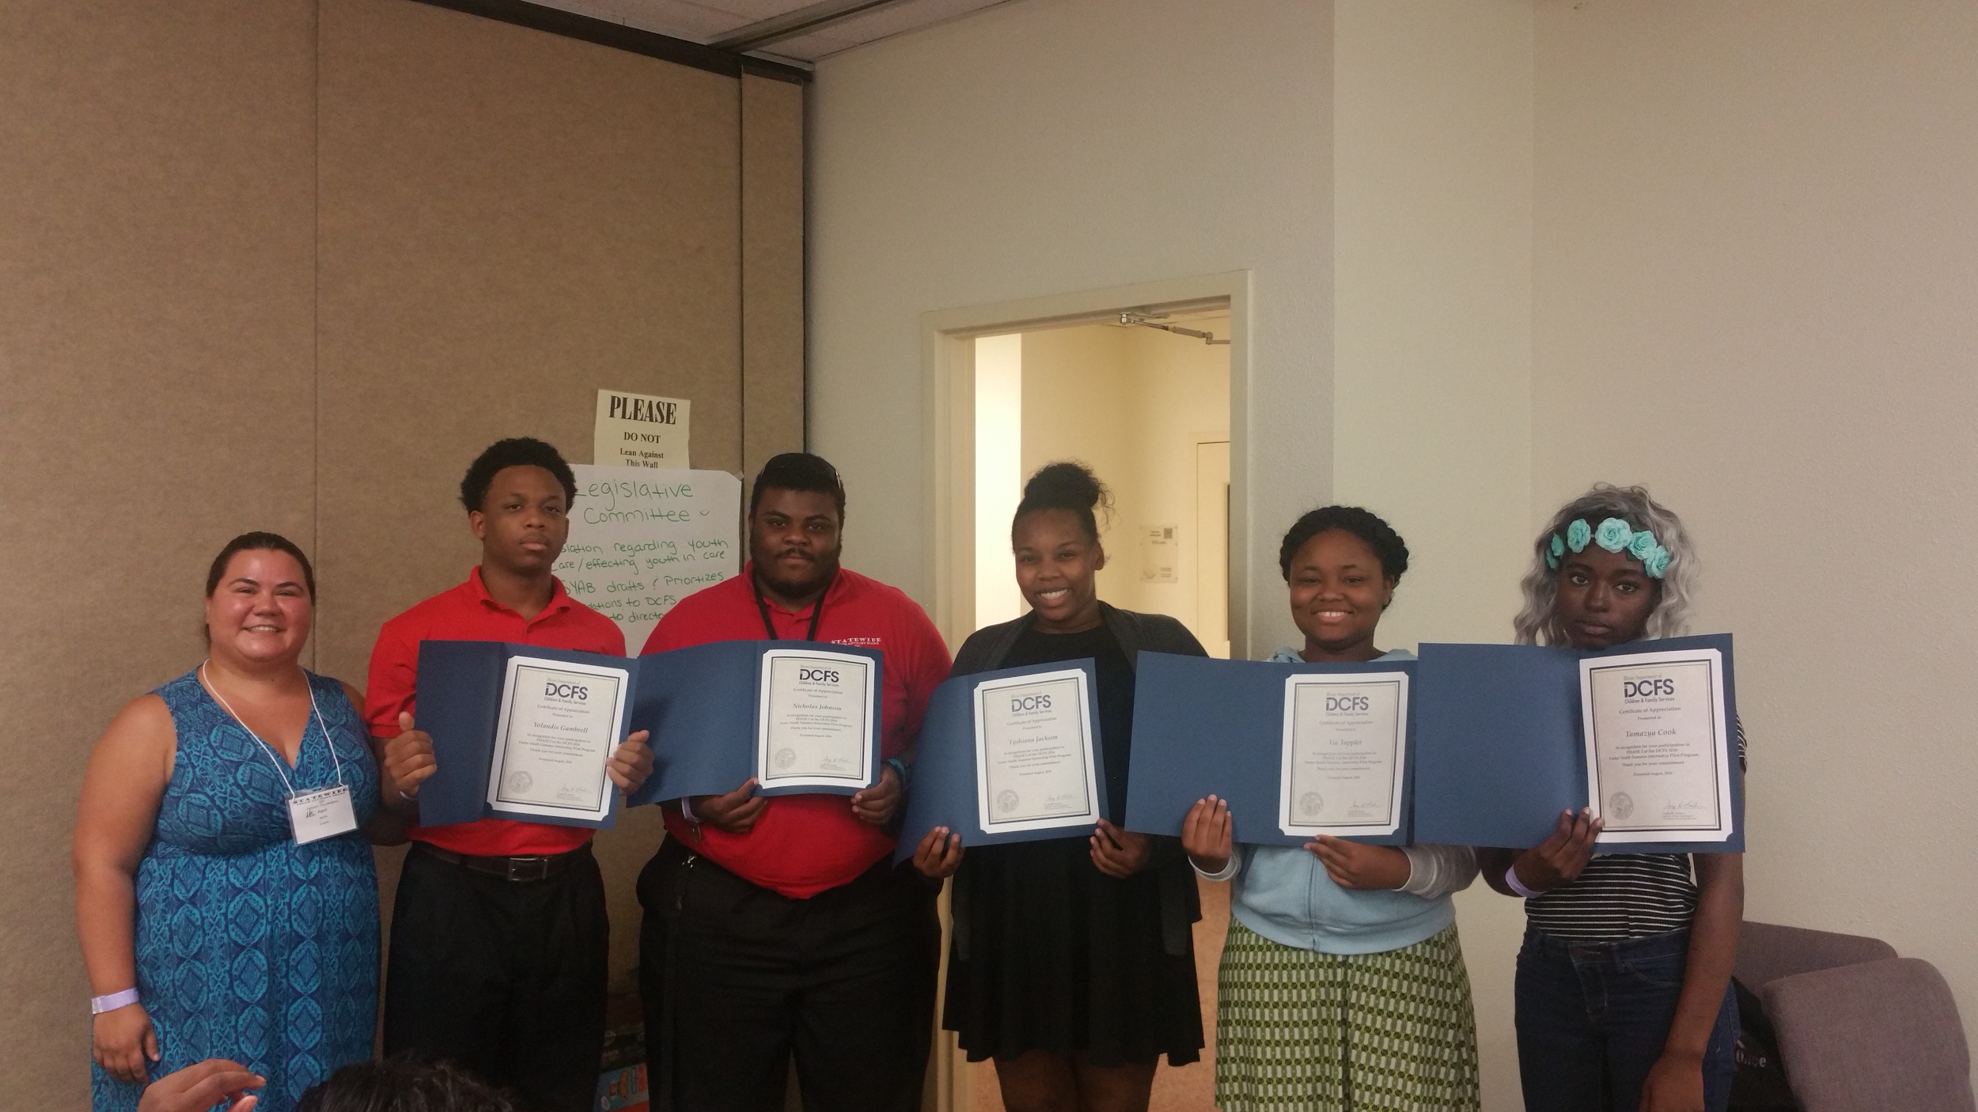

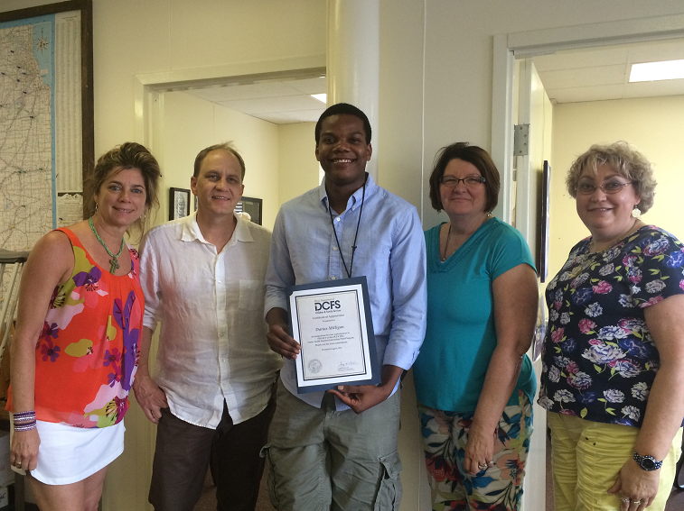

Data from Year One of the Pilot
Summer Employment Pre-Survey and Post- Survey Data: Year One

There were a total of six participants in the Foster Care Youth Summer Employment Pilot program, all six completed the pre and post survey.

Demographic Information:
Age: Average age of participants was 18.8 years.
Race: All participants identified themselves as Black or African American.
YAB Involvement: Two of the participants have been a member of the YAB for five and six years; the other four have been members for less than one year.
Education: Only five of the participants completed this section. Four of the participants are currently enrolled in college and one is a junior in High School.

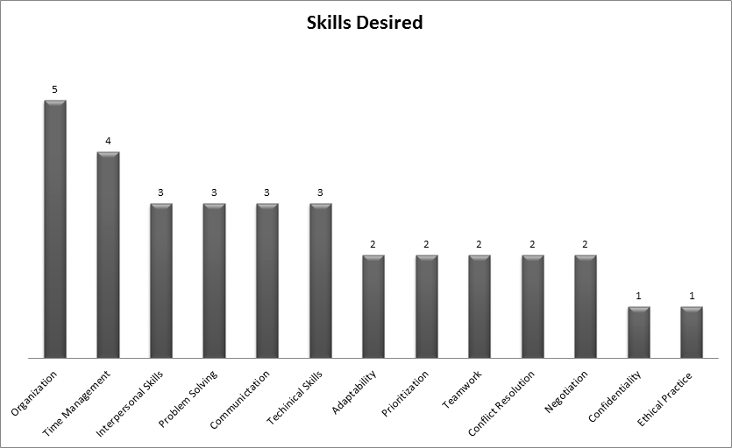

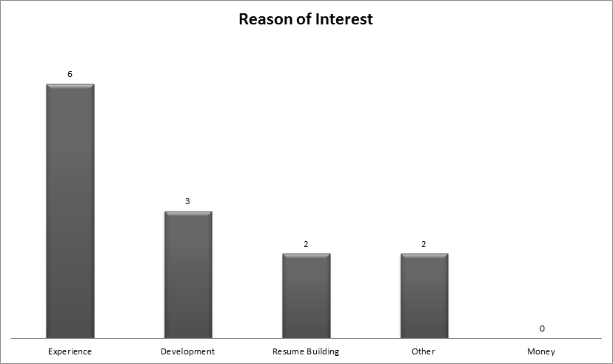

SUMMER CARE FOSTER INTERNSHIP PILOT PLACEMENTS
Year One
July 11, 2016 through August 5, 2016

REGION | ASSIGNED WORK UNIT | LOCATION | SUPERVISOR | START DATE
COOK
Tia Tapper | OES | *100 W Randolph, Chicago | Tracie Crockrell | July 11, 2016
Central
Nicholas Johnson | Pride Program | *2125 S. 1st, Champaign | Sharva Hampton Campbell | July 11, 2016
Tysiana Jackson | Payroll | *4 West Old State Capitol, Spfld | Marie Meadows | July 11, 2016
Darius Milligan | Adm Services | *406 E. Monroe, Springfield | Cindy Mills | July 11, 2016
Southern
Tomazya Cook | Program Manager | *10 Collinsville Ave., E. St. Louis | Vendetta Dennis | July 11, 2016
Yolandis Gambrell | Grant Accountability | *10 Collinsville Ave., E. St. Louis | Derek Hobson | July 18, 2016

Year Two Report
*Please note: This plan was altered and changed accordingly to fit the needs of the Year Two Pilot

Preparation for Program Implementation
The Work Group met on an average of weekly to biweekly to discuss the progress of various assignments, to address issues or concerns which would arise. Geny Chiaradonna (Office of Employee Services), Lynda Swan-McClendon (Office of Employee Transition Services) and Toccara Steele (Office of Learning and Professional Development) made up the workgroup for Year Two of the pilot.
The Work Group worked with the YAB representatives across the state to share information about this opportunity.
Posting notices for the student worker pilot were posted to CMS employment website early May for a 10 day period. Lynda Swan McClendon and Toccara Steele addressed questions from private agencies regarding the posting notices and from YAB.
Summary of the Response to Posting
For year two of the pilot, thirteen applications were received. Five applicants were interviewed and chosen.
Wrap Up: Summary of Year Two and Outcomes
Even though the interns learned from their experience, they weren’t engaged as those interns from the previous year. Due to the interns being a part of the YAB, there were mandatory outings which affected the program due to the mandatory attendance needed from the interns. The Lunch and Learn attendance was low on many Fridays, or the host would have to remind the interns about the call. Many youth were having issues with coming to their placements on time. Transportation was an issue for one youth. We changed the location of their placement after they youth brought this our attention. After this change, the youth report to her placement and never showed up again. Some youth failed to complete their time sheets in a timely manner.
Further Recommendations
The Work Group believes it was a positive pilot for youth in care to learn more about the skills needed to succeed as adults. Also, it was great for supervisors who were willing to assist. However, the Work Group recommends further assessment for potential structural changes before transitioning the pilot to a permanent DCFS program.

DCFS Youth Internship Year Two Program Plan
Plan of Action Developed by the Work Group
Year Two
Qualifying Criteria for Applicants:
- Illinois youth in care between the ages of 16 and 18
  - The exception was made for some who were over the age of 18 to participate.
- Currently enrolled in high school, to include children in alternative schools or those being home schooled
- Must be an active member of the DCFS Youth Advisory Board
Dates and Times of Instruction for the Program:
The interns were expected to work from 8:30 a.m. to 5:00 p.m., Monday through Friday.
- Week 1: Monday, June 26 through Friday, June 30, 2017
- Week 2: Monday, July 3 through Friday, July 7, 2017
- Week 3: Monday, July 10 through Friday, July 14, 2017
- Week 4: Monday, July 17 through Friday, July 21, 2017
- Week 5: Monday, July 24 through Friday, July 28, 2017

Interns were required to attend “Lunch and Learn” sessions each Friday from 1:00 p.m. to 2:00 p.m. Interns were debriefed regarding how the objectives learned the previous week were applied.

Proposed Sites for the Selection and Placement Process for Year 2:
Aurora, Chicago, Champaign-Urbana, East Saint Louis, and Springfield
The selection of these cities was based on the population of members within the DCFS Youth Advisory Board.
The Scheduling and Selection of the Interview Committee for Rutan Interviews:
- Upon receiving and selecting candidates for the positions, interview site(s) were identified.
- Rutan Certified Interviewers conducted the interviews.
- Interviews to begin being conducted first part of June.

Creation and Alterations of CMS Job Posting:
The Department anticipates having the position posted as early as the first week of May and will be posted for 10 days.
The following will be covered by OES:
Payroll for the Interns; OES will arrange the pay schedule; Paperwork and Additional Department Documents
The Office of Learning and Professional Development will be responsible for assigning the placements for the selected interns with the assistance of Lynda McClendon.
The following are some of the divisions identified for Year Two of the pilot:
The Director’s Office, Office of Learning and Professional Development, Business Office, and the Office of Education and Transition Services
Learning Objectives:
The Department will be developing objectives for the interns to gain in alignment with the Public Act 099-0285 stating “Interns are to receive professional training and experience.”
Some skill sets we are looking to focus on are the following but are not limited to:
Flexibility ; Communication; Conflict Resolution; Workplace etiquette, attire, and practices; and Money Management.
Evaluation Tools:
The Department developed a strategy to capture the experiences from a pre and post perspectives from both the intern and the supervisor. A survey using closed ended questions will be completed to provide information for reports prior to and after Year Two of the pilot. Gaining this information will allowed for us to collect data which will later be compared to Year Two of the program. We are looking to use the same tools for Year Two of this pilot.

Data from Year Two of the Pilot

Summer Employment Pre-Survey and Post- Survey Data: Year Two

There were a total of five participants in the Foster Care Youth Summer Employment Pilot program, all five completed the pre-survey. Only three completed the post-survey.

Demographic Information:
Age: Average age of participants was 18.8 years.
Race: Four participants identified themselves as Black or African American. One participant we are unsure of their race.
Location: All of the participants lived and where placed in the Cook County Region
YAB Involvement: Two of the participants have been a member of the YAB for more than five years; one who has been a part for two and half years, one for five years and another for six years.
Education: Three of the participants were enrolled in college or about to start college. Two were in high school.

Skills Looking to Obtain for the Internship

Reasons Why Participants Applied

Areas Where Confidence Was Gained after the Completion of the Pilot

*Data based on the responses of three interns who completed the pilot

Year Two Placement Assignment for Interns

SUMMER CARE FOSTER INTERNSHIP PILOT PLACEMENTS
Year Two
June 26, 2017 through July 28, 2017

REGION | ASSIGNED WORK UNIT | LOCATION | SUPERVISOR | START DATE
COOK
Tia Tapper | OLPD | *6201 S. Emerald, Chicago | Toccara Steele | June 26, 2017
**Charlise Fenderson-Collins | OLPD | *6201 S. Emerald, Chicago | Toccara Steele | June 26, 2017
Kalynn Lane | Office of Education and Transition Services | *100 W. Randolph, Chicago | Darlene Cannon | June 26, 2017
Shania Onipede | Business Office | *17 N. State Street, Chicago | Dahra Parenteau | June 26, 2017
Jesse  Modjeski | Director’s Office | *100 W. Randolph, Chicago | Jeremy Harvey | June 26, 2017

** Due to the location of her internship, we made arrangements for her to serve as an intern under the leadership of Michelle Jackson. Unfortunately, the intern didn’t finish out her placement as she became a “No call, No Show.”

