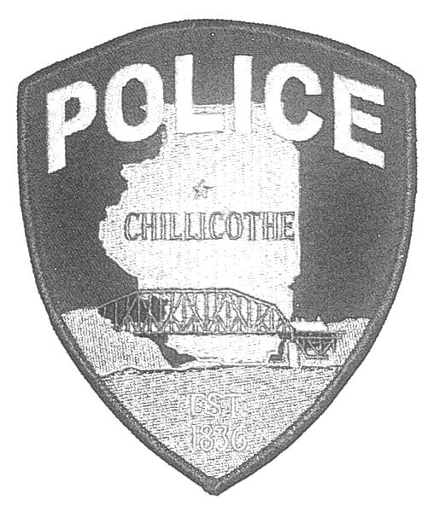

 |  | Chillicothe Police Department |  |  |  |  | Scott M. Mettille
 |  | 823 N. Second Street - Chillicothe, IL 61523 |  |  |  |  | Chief of Police
 |  |  |  |  |  |  | Phone: 309-274-2129
 |  |  |  |  |  |  | Fax: 309-274-3930

Officer-worn Body Camera Annual Report

The Chillicothe Police Department is currently made up of 11 full time sworn officers and 1 Chief of Police. Of the 11 officers there are 3 Sergeants, 1 Detective, and 2 School Resource Officer. All of the officers have an officer-worn body camera. The 11 cameras were put into service after all officers received the general order and proper training.
Body worn cameras were put into service on Oct 5th of 2018. Any and all issues with the body cams were promptly taken care of by the manufacture warranty.
As per our general order, the Sergeants will randomly review the recordings to ensure digitally recorded data is properly downloaded. The Chief of Police or his designate will flag related video when a complaint regarding a department member has been filed, or when the officer is the subject of an internal investigation or otherwise being investigated for possible misconduct. Department supervisors are authorized to view recordings for the following reasons. To investigate a complaint against an officer or a specific incident in which the officer was involved. To identify videos for training purposes and for instructional use. When officers have had a pattern of allegation of abuse or misconduct. For any reason consistent with this directive or as ordered by the Chief.
A copy of the general order and the list of officers, can and will be available upon request.

