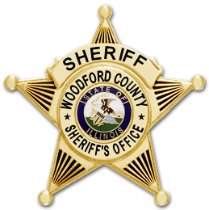
WOODFORD COUNTY SHERIFF’S OFFICE
Matthew L Smith
Sheriff

The Woodford County Sheriff’s Office received grant funding from the State of Illinois in FY 18-19 cycle for the reimbursement of the purchase for one in car dash mount camera in the amount of $4,995. This camera was installed during May 2019 in one of our patrol vehicles.

Supervisor review of such media is strictly regulated by our union agreement with the Fraternal Order of Police contract which is signed by the County. Supervisors may review archived media for two reasons. One, citizen complaint and secondly, routine preparation for court proceedings. If misconduct is found while executing either of these two reasons for search that misconduct may be brought forward.

