**Section 725.TABLE A Rulemaking Chart**

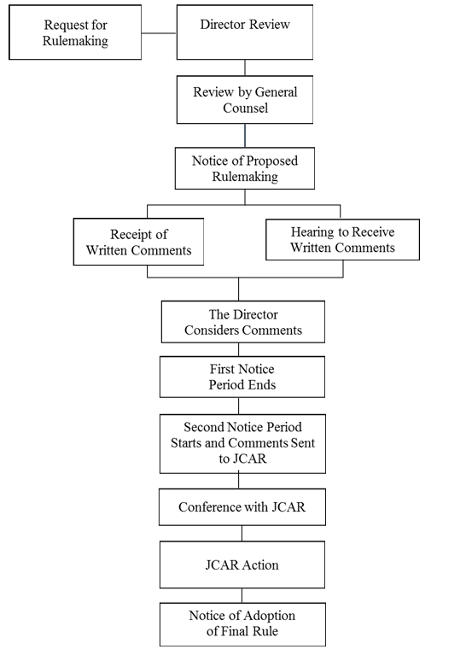

(Source: Added at 43 Ill. Reg. 13289, effective October 30, 2019)