Section 1200.TABLE A Organizational Chart

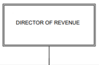
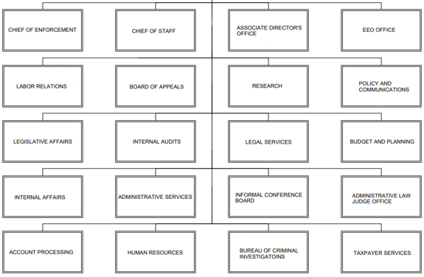

(Source: Amended at 48 Ill. Reg. 5192, effective March 15, 2024)

