**Section 1030.ILLUSTRATION A Map of Regions**

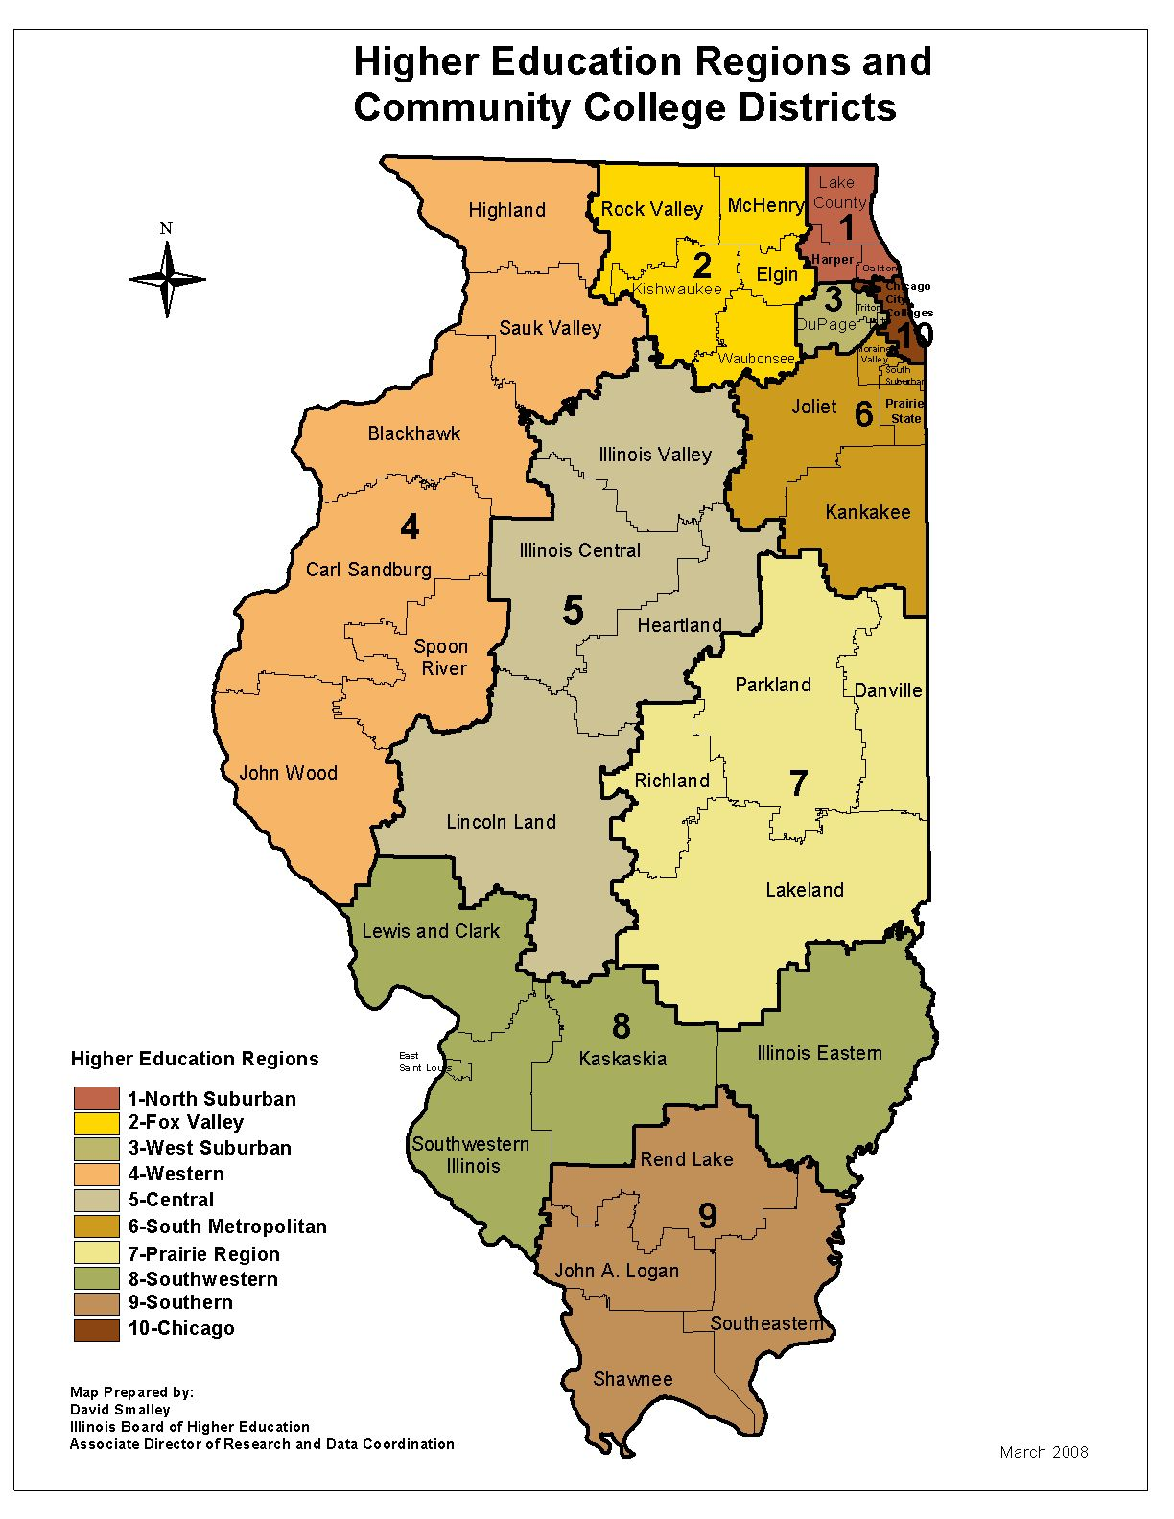

(Source: Added at 32 Ill. Reg. 49, effective December 23, 2008)