**Section 380.APPENDIX A Map of Illinois Sections**

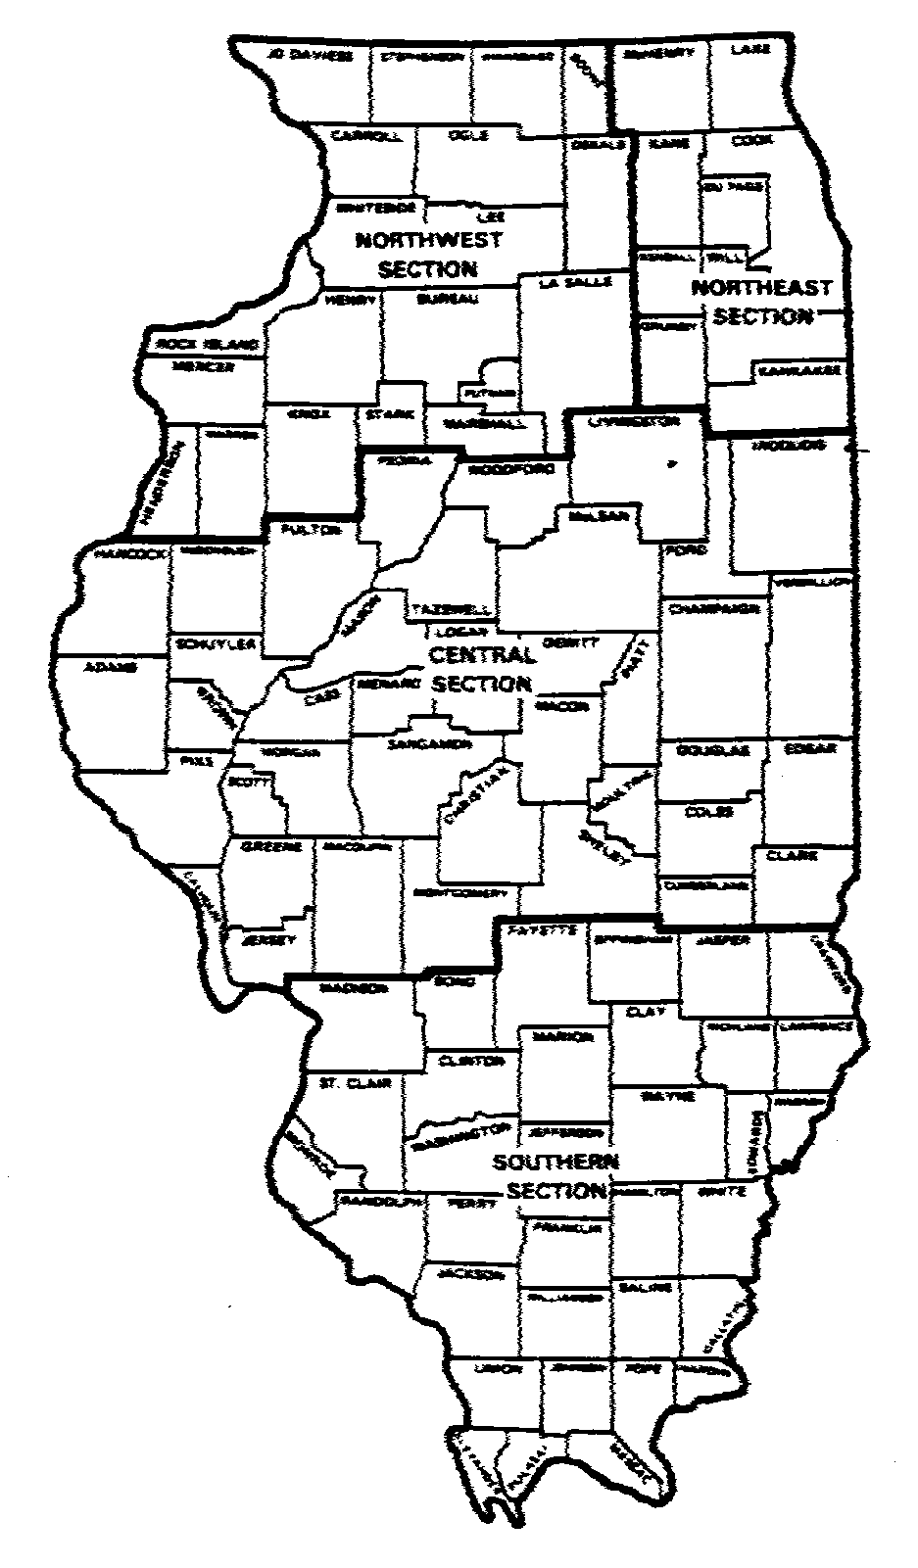

(Source: Amended at 9 Ill. Reg. 2663, effective February 15, 1985)