Section 800.APPENDIX A Regional Offices

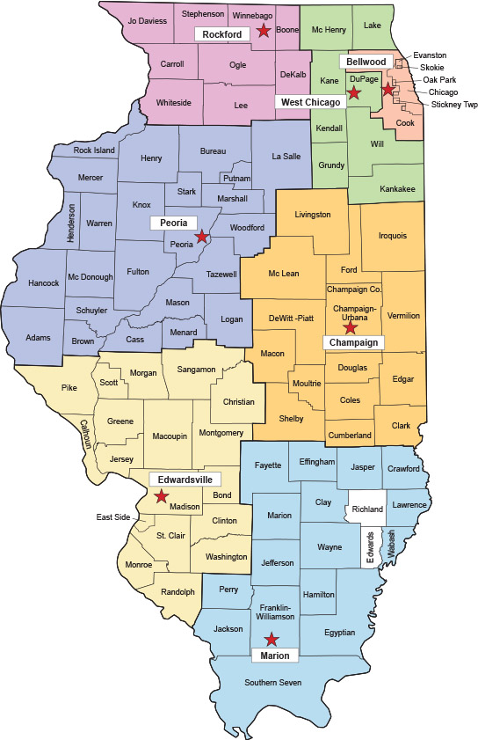
Rockford Region
Regional Manager
4302 North Main Street
Rockford, IL 61103
(815) 987-7511
Peoria Region
Regional Manager
5415 North University
Peoria, IL 61614
(309) 693-5360
Edwardsville Region
Regional Manager
22 Kettle River Drive
Edwardsville, IL 62025
(618) 656-6680
Marion Region
Regional Manager
2309 West Main
Marion, IL 62959
(618) 997-4371
Champaign Region
Regional Manager
2125 South First Street
Champaign, IL 61820
(217) 333-6914
West Chicago Region
Regional Manager
245 W. Roosevelt Rd., Bldg, 5
West Chicago, IL 60185
(708) 293-6800
Bellwood Region
Regional Manager
4212 West St. Charles Road
Bellwood, IL 60104
(708) 544-5300
CENTRAL OFFICE – Springfield
Chief
Division of Environmental Health
525 West Jefferson Street
Springfield, IL 62761
(217) 782-5830
Manager of General Engineering
Division of Environmental Health
525 West Jefferson Street
Springfield, IL 62761
(217) 782-5830

(Source: Amended at 47 Ill. Reg. 4326, effective March 17, 2023)

