**Section 820.APPENDIX A Illustrations**

**Section 820.ILLUSTRATION C General Pool Diving Area Dimensions**

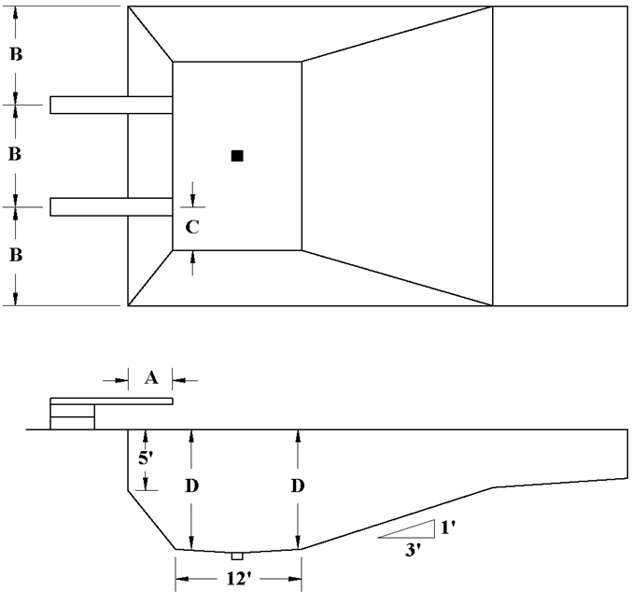

|  |  |  |  |
| --- | --- | --- | --- |
| Minimum Distance Indicated | ≤ 0.5 M | 1M | 3M |
| A – End Wall to Tip of Board | 3' | 5' | 5' |
| B – Center of Board to Sidewall or Adjacent Board | 10' | 10' | 12' |
| C – Center of Board Laterally to Point of Required Depth | 4' | 4' | 6' |
| D – Depth at End of Board and for 12' Beyond | 9.5' | 10' | 12' |

* As an alternate to the minimum wall depth of 5 feet below the water level, the wall may be vertical for a depth of 3 feet below the water level, below which it may be curved to the bottom with a radius equal to the difference between the depth at the bottom and the depth at the point of curvature.

(Source: Amended at 37 Ill. Reg. 16539, effective October 4, 2013)