**Section 890.APPENDIX B Illustrations for Subpart A**

**Section 890.ILLUSTRATION Z Yoke Vent<br> Section 890.ILLUSTRATION AA Sleeves<br> Section 890.ILLUSTRATION BB Buried Piping Parallel to Footing<br> Section 890.ILLUSTRATION CC Individual Dry Vent**

(Referenced in Section 890.120, Definition of "Yoke Vent.")

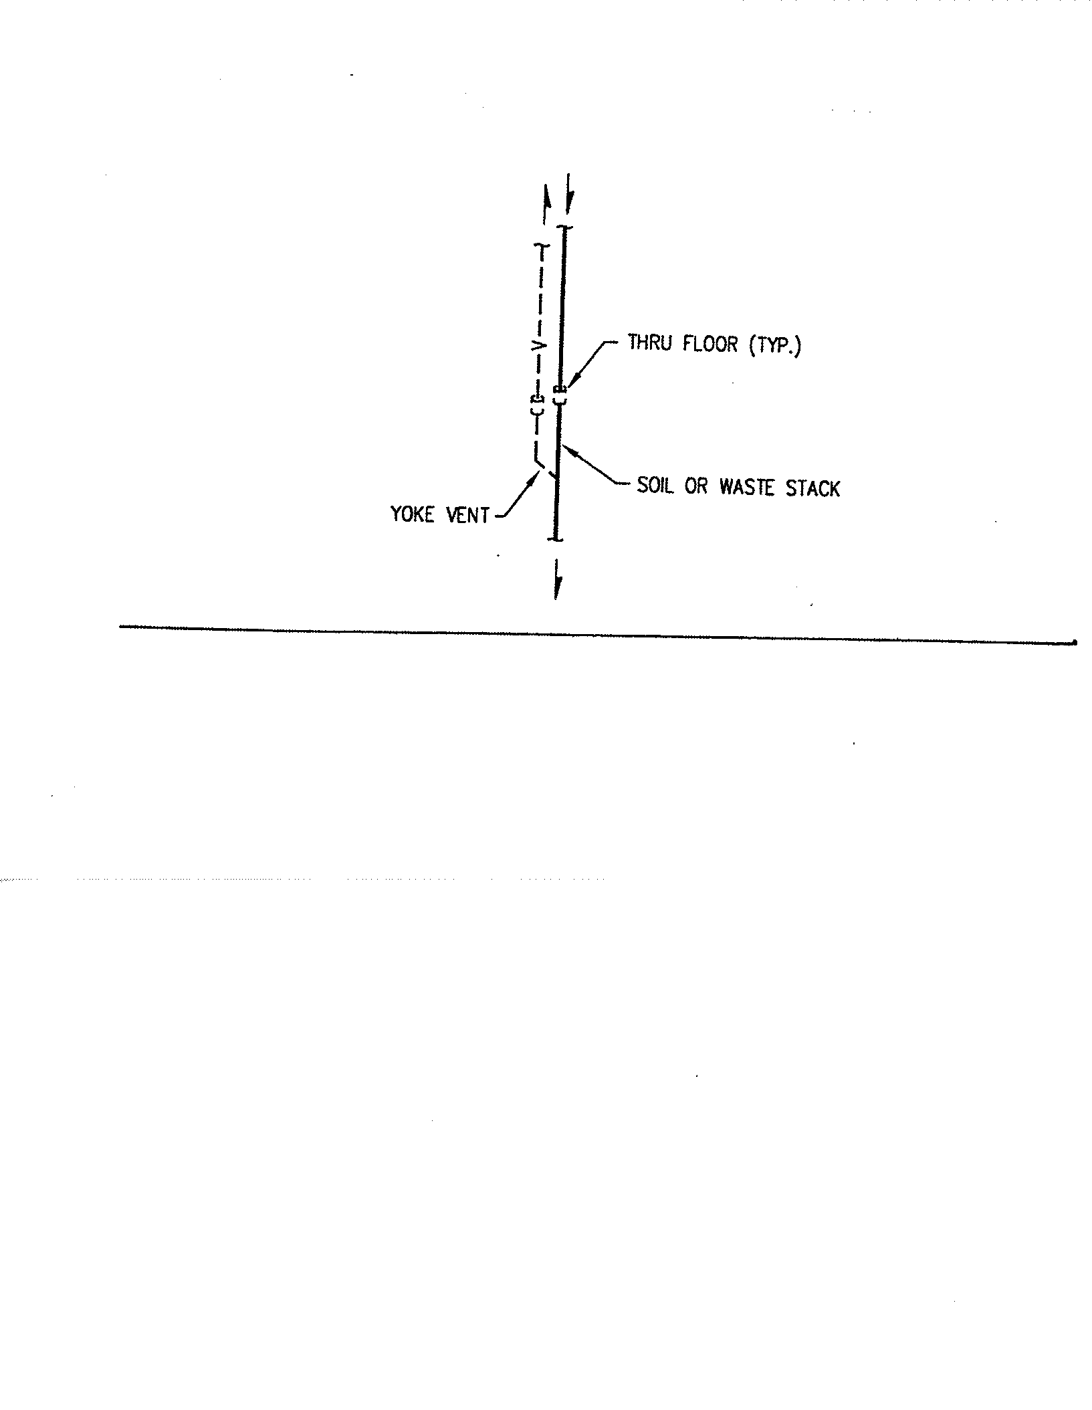

(Source: Amended at 38 Ill. Reg. 9940, effective April 24, 2014)

**Section 890.APPENDIX B Illustrations for Subpart A**

**Section 890.ILLUSTRATION AA Sleeves**

(Referenced in Section 890.180(c) and (d))

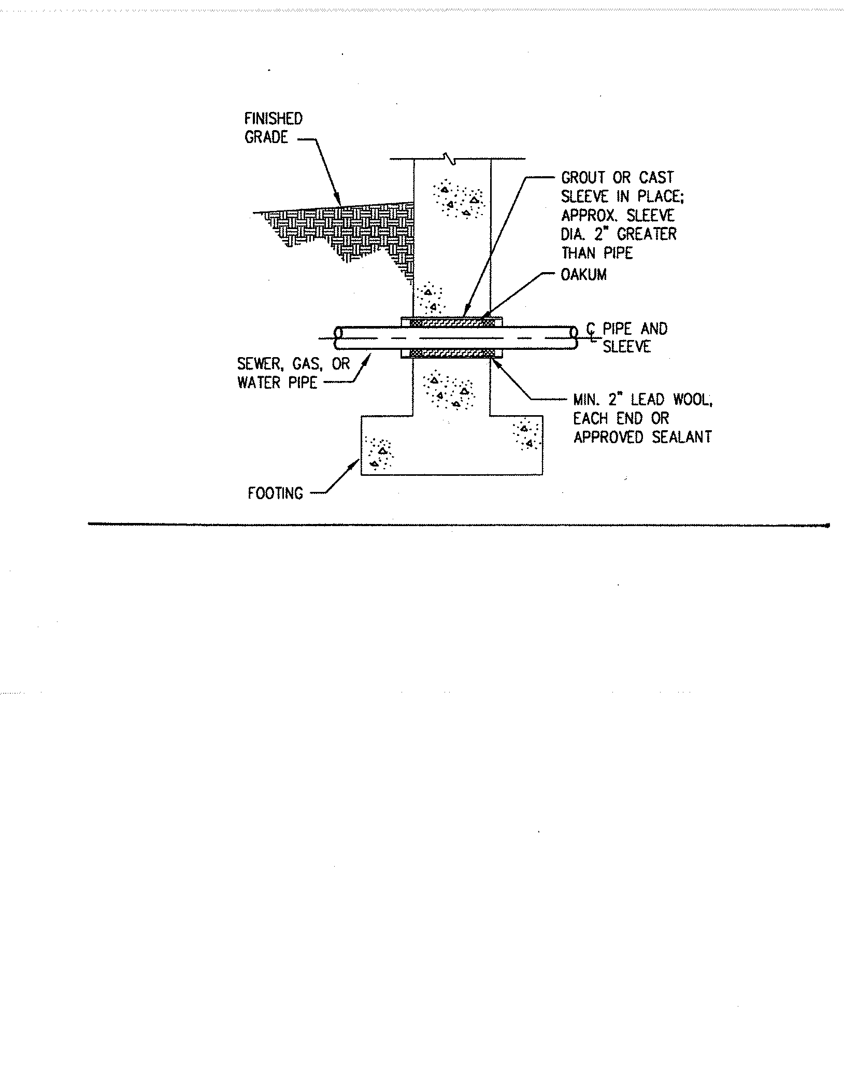

(Source: Amended at 38 Ill. Reg. 9940, effective April 24, 2014)

**Section 890.APPENDIX B Illustrations for Subpart A**

**Section 890.ILLUSTRATION BB Buried Piping Parallel to Footing**

(Referenced in Section 890.180(e) and (f))

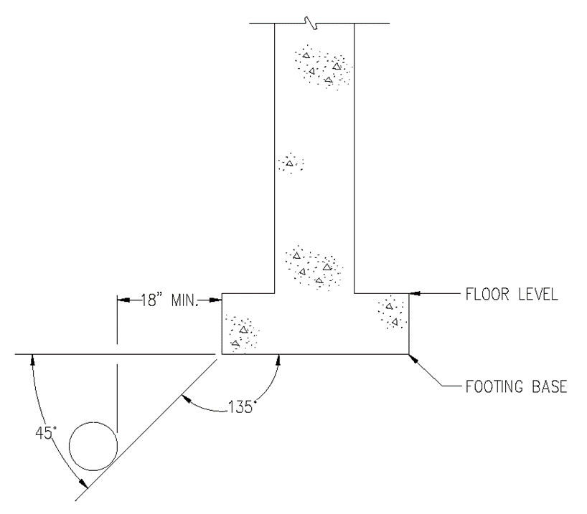

(Source: Added at 38 Ill. Reg. 9940, effective April 24, 2014)

**Section 890.APPENDIX B Illustrations for Subpart A**

**Section 890.ILLUSTRATION CC Individual Dry Vent**

(Referenced in Section 890.120, Definition of "Individual Dry Vent.")

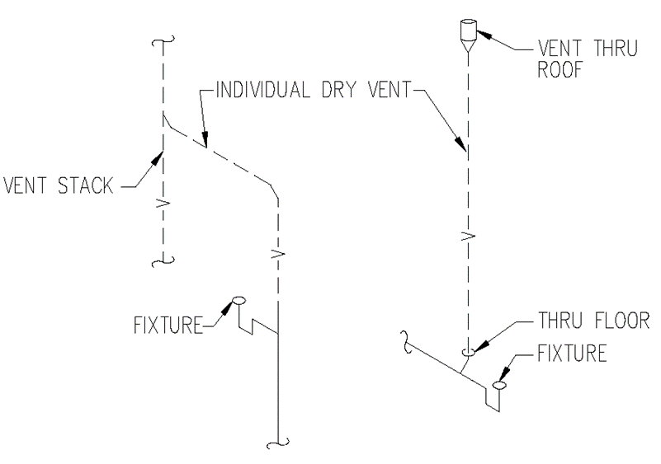

(Source: Added at 38 Ill. Reg. 9940, effective April 24, 2014)