**Section 890.APPENDIX C Illustrations for Subpart C**

**Section 890.ILLUSTRATION C Positions of Application for Compression Type Joints**

(Referenced in Section 890.320(o)(1))

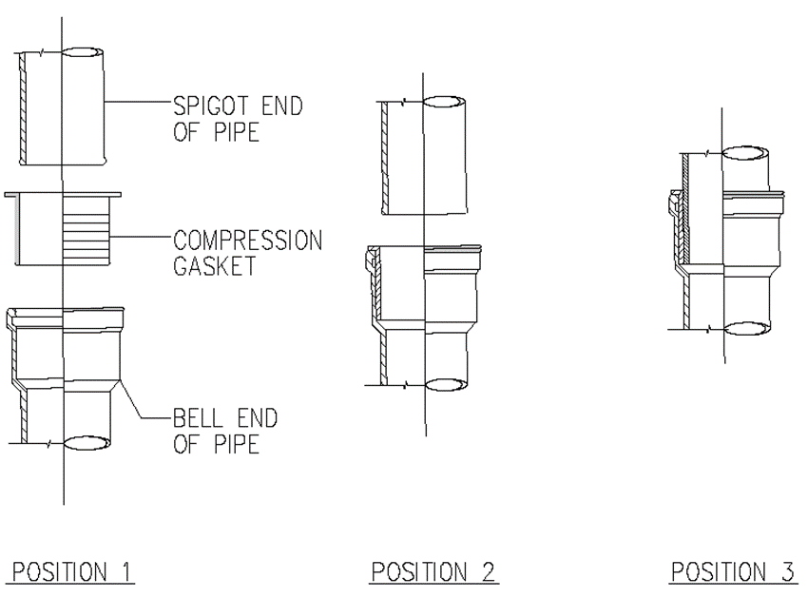

(Source: Amended at 38 Ill. Reg. 9940, effective April 24, 2014)