**Section 890.APPENDIX I Illustrations for Subpart I**

**Section 890.ILLUSTRATION C Cross-Connection #3**

(Referenced in Section 890.1130(a))

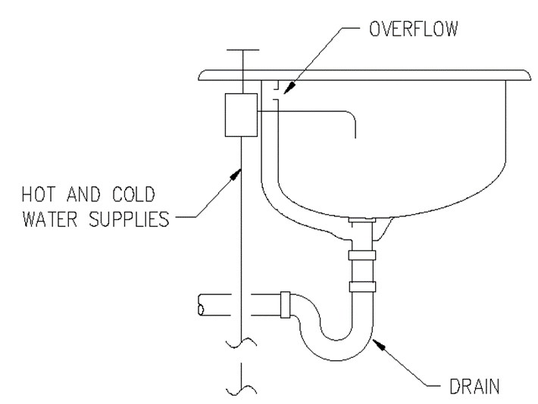

(Source: Amended at 38 Ill. Reg. 9940, effective April 24, 2014)