**Section 890.APPENDIX I Illustrations for Subpart I**

**Section 890.ILLUSTRATION H Water Supply Control**

(Referenced in Section 890.1190(a) & (b))

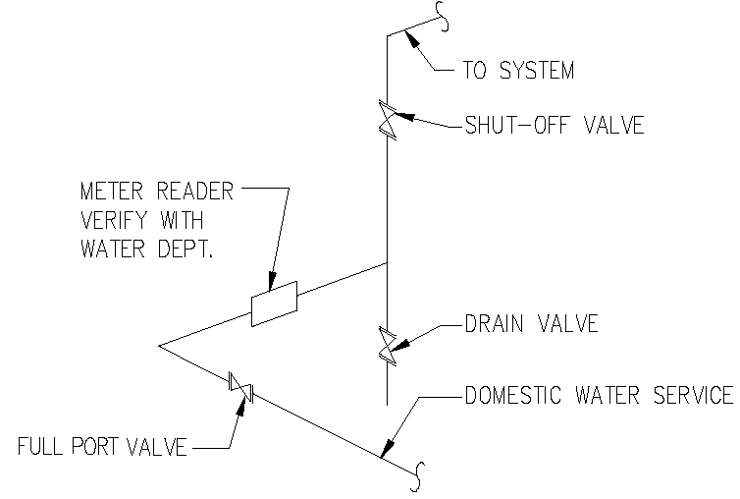

(Source: Amended at 38 Ill. Reg. 9940, effective April 24, 2014)