Section 890.APPENDIX I Illustrations for Subpart I

Section 890.ILLUSTRATION M Typical Electric Water Heater

(Referenced in Section 890.1220(a))

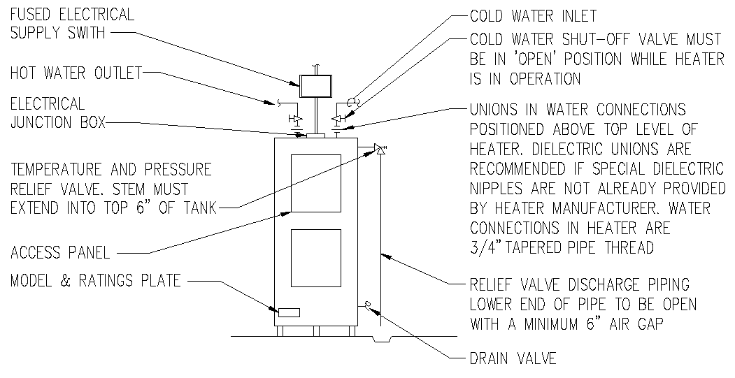
(Source: Amended at 38 Ill. Reg. 9940, effective April 24, 2014)

