Section 890.APPENDIX J Illustrations for Subpart J

Section 890.ILLUSTRATION E Fixture Connections

(Referenced in Section 890.1320(l))

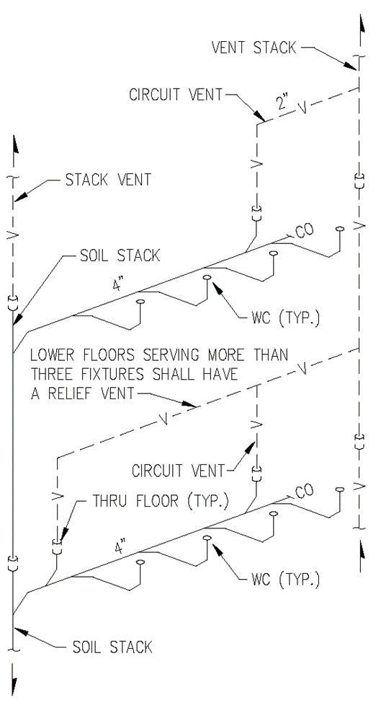

(Source: Amended at 38 Ill. Reg. 9940, effective April 24, 2014)

