**Section 890.APPENDIX J Illustrations for Subpart J**

**Section 890.ILLUSTRATION G Offsets on Drainage Piping**

(Referenced in Section 890.1350(a))

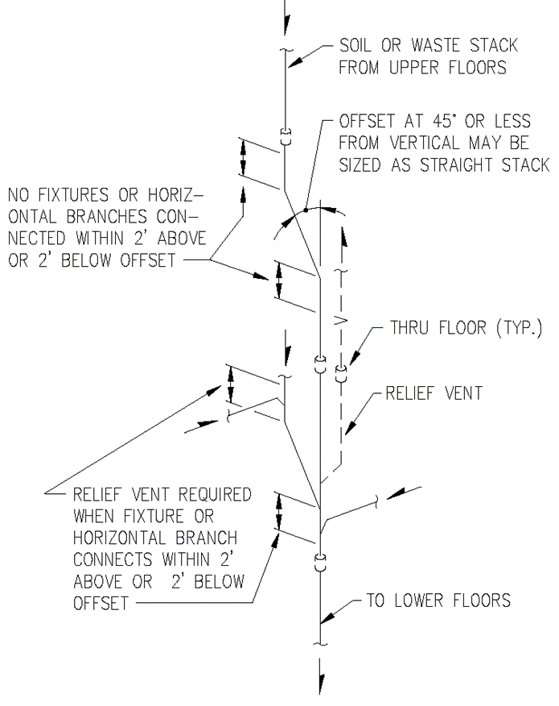

(Source: Amended at 38 Ill. Reg. 9940, effective April 24, 2014)