**Section 890.APPENDIX J Illustrations for Subpart J**

**Section 890.ILLUSTRATION J Below Lowest Branch**

(Referenced in Section 890.1350(d))

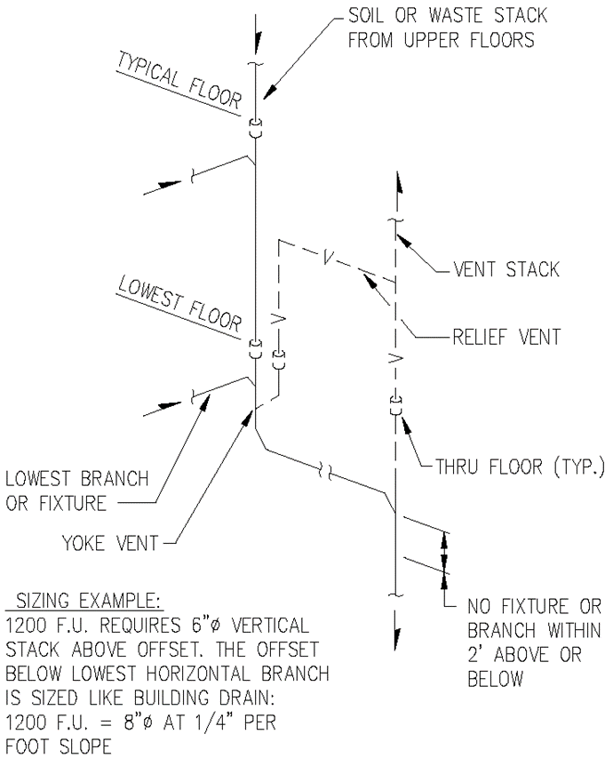

(Source: Amended at 38 Ill. Reg. 9940, effective April 24, 2014)