**Section 890.APPENDIX J Illustrations for Subpart J**

**Section 890.ILLUSTRATION K Drainage Below Sewer Level**

(Referenced in Section 890.1360(a)(1))

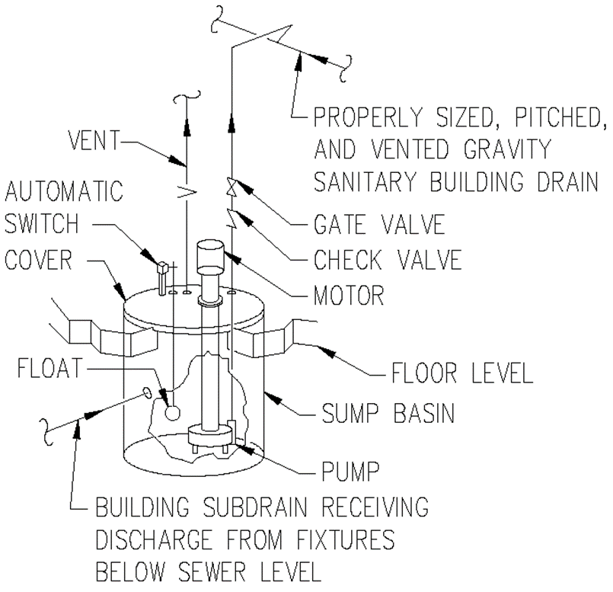

(Source: Amended at 38 Ill. Reg. 9940, effective April 24, 2014)