**Section 890.APPENDIX K Illustrations for Subpart K**

**Section 890.ILLUSTRATION N Trap Weir/Hydraulic Gradient**

(Referenced in Section 890.1470(b) and (d))

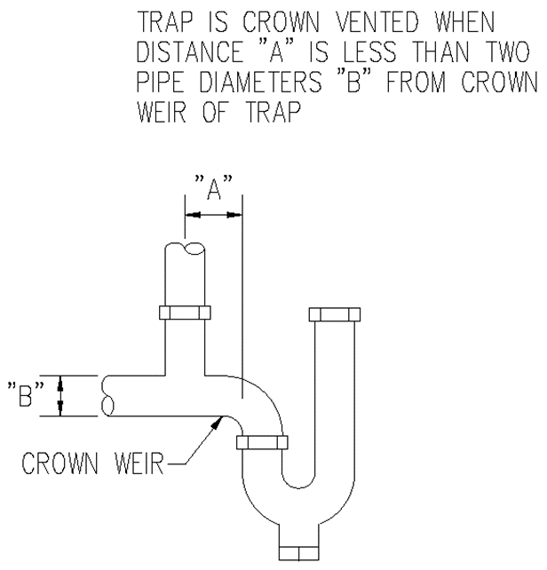

(Source: Amended at 38 Ill. Reg. 9940, effective April 24, 2014)