Section 890.APPENDIX K Illustrations for Subpart K

Section 890.ILLUSTRATION T Bathroom Group Back to Back

(Referenced in Section 890.1500(g)(1) through (4))

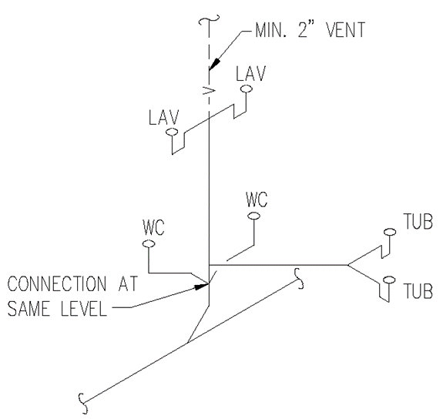

(Source: Amended at 38 Ill. Reg. 9940, effective April 24, 2014)

