**Section 905.APPENDIX A Illustrations and Exhibits**

**Section 905.ILLUSTRATION G Instructions for Conducting Percolation Tests**

Percolation tests shall not be made in frozen ground or ground that has been filled in the preceding 12 months. Percolation tests shall be performed in accordance with the following procedures:

1. Number and Location of Percolation Tests. Select an area where the seepage field will be located. When digging the holes, avoid animal burrows, large root channels, etc. At least 3 separate percolation tests shall be performed at the site of each proposed disposal area. The percolation test holes shall be at least 50 feet apart. At least one hole shall be located at the lowest elevation of the proposed absorption field area. The 2 holes with the highest results shall be used to determine percolation rate.

2. Depth of Percolation Test Hole. Dig or bore the holes with horizontal dimensions approximately 4 to 6 inches in diameter to the depth of the proposed seepage field or seepage bed.

3. Preparation of Test Hole.

a) Carefully pick the bottom and sides of the hole with a knife blade or sharp pointed instrument to remove smeared or smoothed soil and to provide a natural soil interface into which water may percolate.

b) Remove all loose material from the hole.

c) Add 2 inches of coarse gravel to protect the bottom from scouring and sediment. A removable hardware cloth screen to line the lower part of the hole also helps prevent sloughing of the hole sides during testing.

4. Saturation and Swelling of Soil: It is important to distinguish between saturation and swelling. Saturation means the void spaces between soil particles are full of water. This can be accomplished in a very short period of time. Swelling is caused by the intrusion of water into the individual soil particle. This is a slow process, especially in a clay type soil and is the reason for requiring a prolonged soaking period.

a) On the day prior to conducting the percolation test, carefully fill the hole with water and keep it full for at least 4 hours. The percolation test shall be conducted on the day following this presoaking at least 18 hours after presoaking is completed but prior to 30 hours after presoaking is completed. Cover the hole during this 18-30 hour waiting period. In sandy soils with greater than 70% sand and less than 15% clay (sand and loamy sand), after the 4 hour presoak, a percolation test may be attempted without the 18 hour waiting period. If the percolation test results are greater than 45 minutes for a 6 inch drop in water, the test must be repeated after the 18 hour waiting period. If the percolation test results are 45 minutes or less, the percolation rate shall be used to size the system.

b) On the day of conducting the percolation test, carefully fill the hole with water to 12 inches above the gravel.

c) Allow the water level to drop to a point 6 inches above the gravel. If the water does not fall from 12 inches to 6 inches in 6 hours, the percolation test is terminated and an alternate system is required.

d) Measure the last 6 inch drop in water level at thirty minute intervals until all the water has seeped away. Warning: Under no conditions shall measurements be taken from water filled to the top of the hole or on water 12 inches deep in the hole. Such results are completely invalid and will not be accepted. Results from the last 6 inches of drop in water are the only results that will be accepted.

5. Recording of Results. Record results of all tests as the total minutes required for the last 6 inches of seepage. If the last 6 inches of water has not seeped away at the end of 6 hours, the soil must be considered unsuitable for seepage field disposal and the appropriate statement marked on the results form. If there is more than a 30 minute difference between the highest 2 percolation tests, use the larger result or perform additional percolation tests.

6. Calculating the Percolation Rate. Add the total minutes required for the last 6 inches of water to fall from the 2 holes with the highest result and divide by 2. If the average is less than 60 minutes, use the percolation rate of 60 minutes. If the average is greater than 60 minutes, refer to Section 905.Appendix A: Illustration H of this Part. Locate in the first column (Time (minutes) required for last 6 inches of water to fall) where the highest 2 hole average fits and use the next highest result as the percolation rate for sizing and design. An example of this procedure is as follows: If 3 percolation tests are conducted with results of 120 minutes, 140 minutes, and 155 minutes, the highest 2 hole average would be (140 + 155)/2 or 147.5 minutes. Looking at Section 905.Appendix A: Illustration H of this Part, the next highest result would be 150 minutes. The 150 minute rate would be used to size and design the subsurface seepage system.

7. Distribution of Results. The results of the percolation tests shall be given to the homeowner and shall be retained by the contractor for at least 5 years. The percolation test data report shall be returned to the appropriate regional office or local authority.

TEST HOLE:

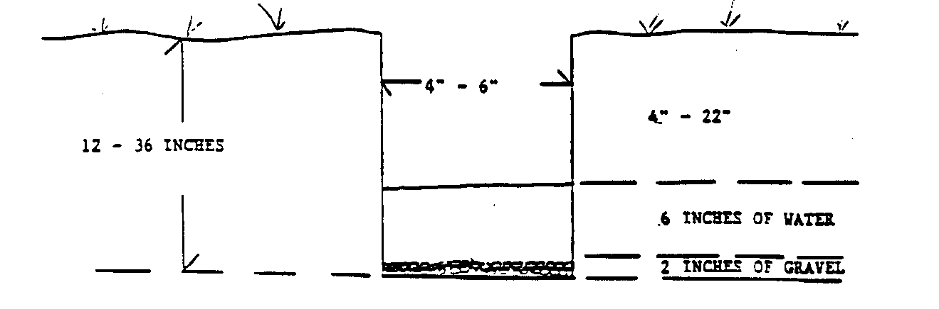

|  |  |  |  |  |  |  |
| --- | --- | --- | --- | --- | --- | --- |
|  | TEST HOLE #1 | | TEST HOLE #2 | | TEST HOLE #3 | |
| READING # | TIME  (in min.) | WATER  LEVEL  (in inches) | TIME  (in min.) | WATER  LEVEL  (in inches) | TIME  (in min.) | WATER  LEVEL  (in inches) |
|  | | | | | | |
| 1 | 0 |  | 0 |  | 0 |  |
| 2 | 30 |  | 30 |  | 30 |  |
| 3 | 60 |  | 60 |  | 60 |  |
| 4 | 90 |  | 90 |  | 90 |  |
| 5 | 120 |  | 120 |  | 120 |  |
| 6 | 150 |  | 150 |  | 150 |  |
| 7 | 180 |  | 180 |  | 180 |  |
| 8 | 210 |  | 210 |  | 210 |  |
| 9 | 240 |  | 240 |  | 240 |  |
| 10 | 270 |  | 270 |  | 270 |  |
| 11 | 300 |  | 300 |  | 300 |  |
| 12 | 330 |  | 330 |  | 330 |  |
| 13 | 360 |  | 360 |  | 360 |  |

(Source: Amended at 20 Ill. Reg. 2431, effective March 15, 1996)