**Section 905.APPENDIX A Illustrations and Exhibits**

**Section 905.ILLUSTRATION N Buried Sand Filter**

**Section 905.EXHIBIT A Plan View**

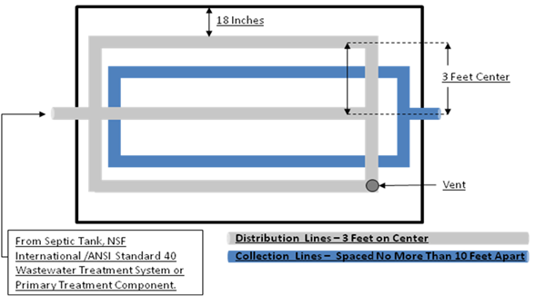

(Source: Amended at 37 Ill. Reg. 14994, effective August 28, 2013)

**Section 905.APPENDIX A Illustrations and Exhibits**

**Section 905.ILLUSTRATION N Buried Sand Filter**

**Section 905.EXHIBIT B Section View**

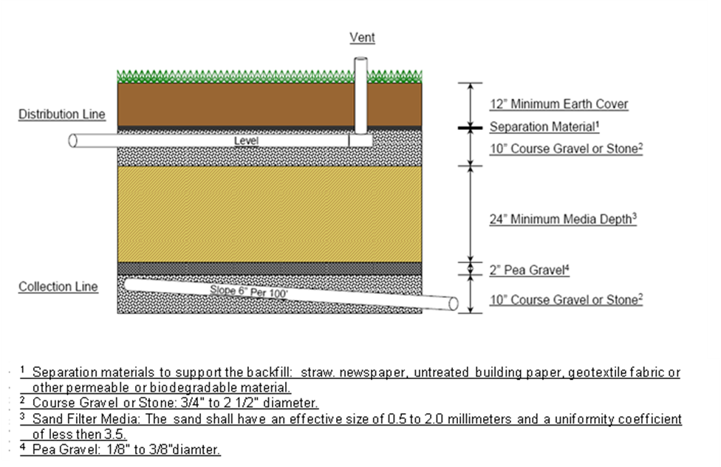

(Source: Amended at 37 Ill. Reg. 14994, effective August 28, 2013)

**Section 905.APPENDIX A Illustrations and Exhibits**

**Section 905.ILLUSTRATION N Buried Sand Filter**

**Section 905.EXHIBIT C End View**

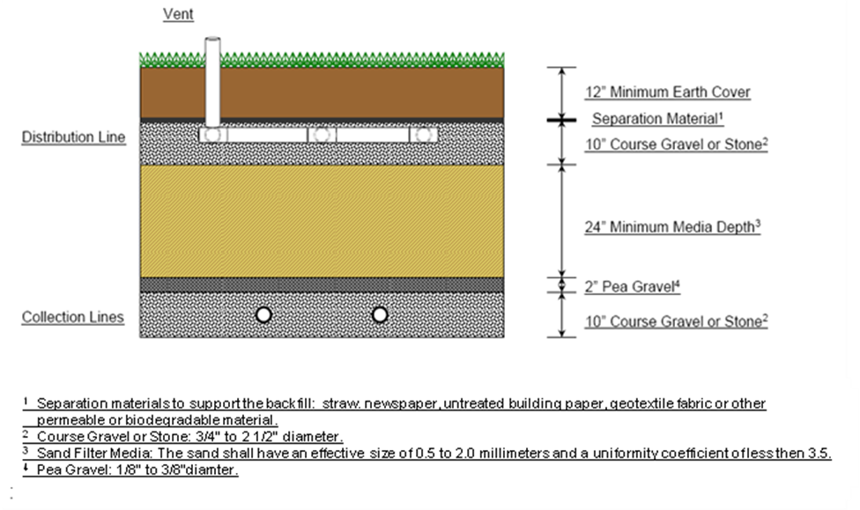

(Source: Amended at 37 Ill. Reg. 14994, effective August 28, 2013)