Section 131.ILLUSTRATION A: Leveling the Playing Field Retailer Flowchart

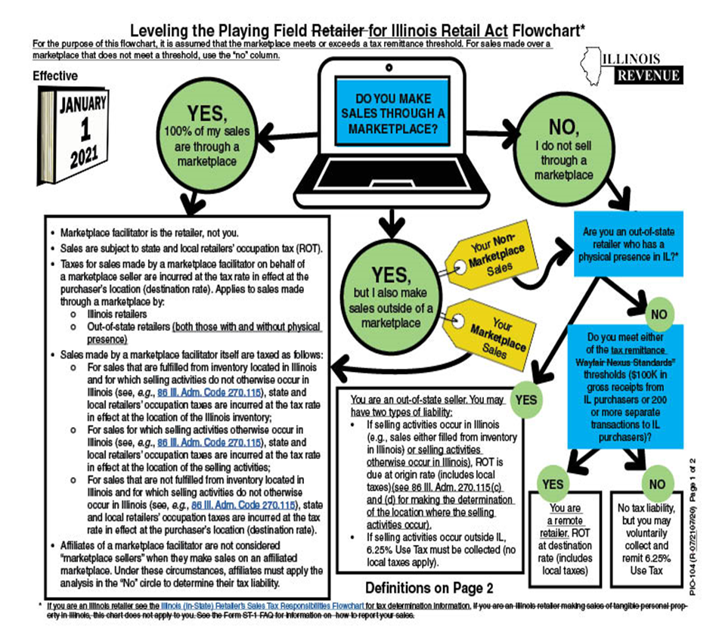

*If you are an Illinois retailer engaged in the occupation of making sales of tangible personal property in Illinois and you make sales over a marketplace, see the "YES" box for the treatment of those sales. If you are an Illinois retailer and do not make any sales over a marketplace, the provisions of this chart do not apply to you and you should handle your liability as you did prior to January 1, 2021.
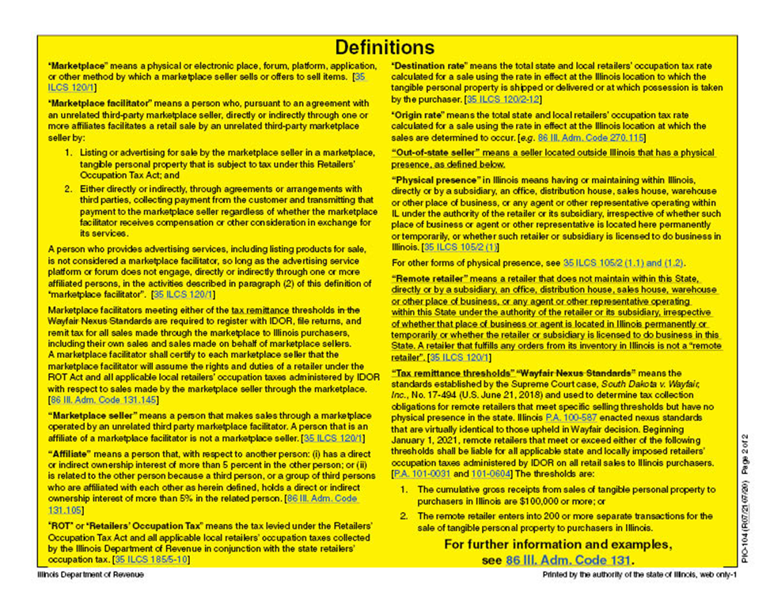

(Source: Amended at 46 Ill. Reg. 2697, effective January 26, 2022)

