TABLE OF CONTENTS
PAGE
- INTRODUCTION 1

- DESCRIPTION OF THE PROBLEM 1

- DESCRIPTION OF THE PROJECT 1

- AUTHORITY AND AUTHORIZATION 2

- PROJECT BENEFITS 2

- PROJECT COSTS 2

- PROJECT FUNDING 3

- ENVIRONMENTAL REVIEW 3

- PROJECT SPONSORSHIP AND FUTURE ACTIONS 3

- LIST OF APPROVED ACQUISITION PROPERTIES 3

EXHIBITS
EXHIBIT 1 MITIGATION PROJECT LOCATION 4
EXHIBIT 2 FLOOD INSURANCE BASE MAP 5
I. INTRODUCTION
This report discusses the flood hazard mitigation project requested by Hamburg and recommended for implementation by the Illinois Department of Natural Resources, Office of Water Resources. The project is for the acquisition and demolition of 7 homes located on 7 parcels at an estimated cost of $419,496. Hamburg is currently working on developing a Hazard Mitigation Plan that recommends that repetitive flood loss properties located within the 100-year floodplain and within the corporate limits of the Village be acquired, demolished, and the site maintained for public open space use, thereby eliminating future flood damages, public flood response expenditures, public subsidized flood insurance claims, and threats to public health.

II. DESCRIPTION OF THE PROBLEM
Village of Hamburg is flood prone with the Mississippi River providing its western boundary. There have been nine homes purchased previously in buyout projects in Hamburg following major floods in 1993 and 2011. All of the properties in this application suffered major flood damage in 2019 and the majority are repetitive loss properties and/or substantial damage properties.

III. DESCRIPTION OF THE PROJECT
The Village of Hamburg Flood Hazard Mitigation Project includes the acquisition and demolition of 7 primary structures on 7 parcels located in the Village. The complete addresses are listed in Section X of this report and their locations can be seen in Exhibit 1. The project also includes clearing of the property acquired and reshaping the property to safe and manageable conditions. Additionally, the project includes the preparation of designs, plans and specifications for the clearing and reshaping of the properties, and acquisition transaction expenses such as title commitments, appraisal costs and recording costs. This project is consistent with the Village’s floodplain management goals contained in its past Hazard Mitigation Plan and the plan being developed.

IV. AUTHORITY AND AUTHORIZATION
Participation in this flood hazard mitigation project by the Department of Natural Resources, Office of Water Resources through its Flood Hazard Mitigation Program is granted under the authority of the “Flood Control Act of 1945,” 615 ILCS 15 (2004 State Bar Edition). The Illinois General Assembly appropriated funds to the Department of Natural Resources under Public Act 98-0050, Article 31, Section 10 for cost sharing to acquire flood prone structures and to implement flood hazard mitigation plans.

V. PROJECT BENEFITS
The acquisition of the floodplain property will greatly reduce the need for future federal and state disaster assistance to affected residents in Village of Hamburg. By removing these structures, the project will reduce the need for public rescues and emergency services during flood conditions within the watershed. Several of these homes are substantially damaged.

The acquisition and demolition of the structures will also allow the Village to expand its public open space holdings. It will give the Village open green space for a large area along the riverfront.

The Department has evaluated the economic feasibility associated with the acquisition of the properties using FEMA’s Benefit Cost module and the first-floor elevations were shot by IDNR’s surveying crew. The FEMA B/C module computed the capitalized value of the flood damage reduction benefits created by the elimination of these structures to be valued at $712,758, which when compared to the costs, $419,496, resulted in a benefit cost ratio of 1.70.

VI. PROJECT COSTS
The total estimated cost, without maintenance costs, of the Village of Hamburg acquisition project is $419,496 including acquisition, asbestos abatement, demolition and clearance of the property to a safe and manageable condition. This also includes the property acquisition transaction expenses (such as title commitments, attorney fees, preparation of legal descriptions, plat drawings, recording costs, associated appraisal costs and, if necessary, associated survey costs or other similar expenses) and management costs. The Department will provide up to $419,496 for the project; this is 100% of the estimated project costs.

VII. PROJECT FUNDING
The Department will participate in the project up to the estimated project cost assuring at least a 1:1 return on the State’s investment. If the project goes over budget, the Village will be responsible for the remainder of the project costs.

VIII. ENVIRONMENTAL REVIEW
To identify any potential environmental impacts to cultural and biological resources associated with the mitigation work proposed, an environmental review was completed by the Illinois Department of Natural Resources. This review concluded that the mitigation work could proceed without any anticipated impacts to the wetlands or threatened or endangered species. As part of the review process, the Illinois Historic Preservation Agency determined that no historic properties, subject to protection under Section 106 of the National Historic Preservation Act of 1996, will be adversely impacted by the mitigation work.

IX. PROJECT SPONSORSHIP AND FUTURE ACTIONS
Prior to expenditure of State Funds for the project, a local governmental entity, known as a project sponsor, must agree to participate in the mitigation project with the Illinois Department of Natural Resources, Office of Water Resources. Village of Hamburg serves as that sponsor for this project through an Intergovernmental Agreement with the Department of Natural Resources. As a project sponsor, Village of Hamburg has agreed to:
- acquire the property in fee with title running in the name of the People of the State of Illinois, Department of Natural Resources, Office of Water Resources, demolish or otherwise remove the improvement(s) on the property acquired, develop the designs, plans and specifications needed, prepare contract documents, solicit bids, award contracts, supervise the work, and perform all other work necessary to complete the project;
- furnish billings to the Department of Natural Resources with supporting documentation as evidence that the work covered under such billing(s) is completed and in connection with the project for reimbursement;
- obtain all federal and state permits, in the name of the Village, as may be necessary to implement and maintain the project;
- pay all project costs over and above the Department’s $419,496 maximum funding obligation;
- maintain in perpetuity the acquired flood prone property in an open, safe, neat and manageable condition from the time of closing with the private owner; and
- maintain eligibility in the National Flood Insurance Program and continue to adopt and enforce appropriate ordinances to satisfy the Federal Emergency Management Agency and the Department’s requirements relative to the regulation of development in floodplains under the jurisdiction and control of the Village.

X List of Approved Acquisition Properties
Property Address PIN
0 Water St. 07-05-35-201-146
3 Water St. 07-05-35-100-023
5 Water St. 07-05-35-201-147
234 N. Water 07-05-35-100-103
410 N. Water 07-05-35-100-025
400 N. Washington 07-05-35-201-151
406 N. Washington 07-08-27-201-152

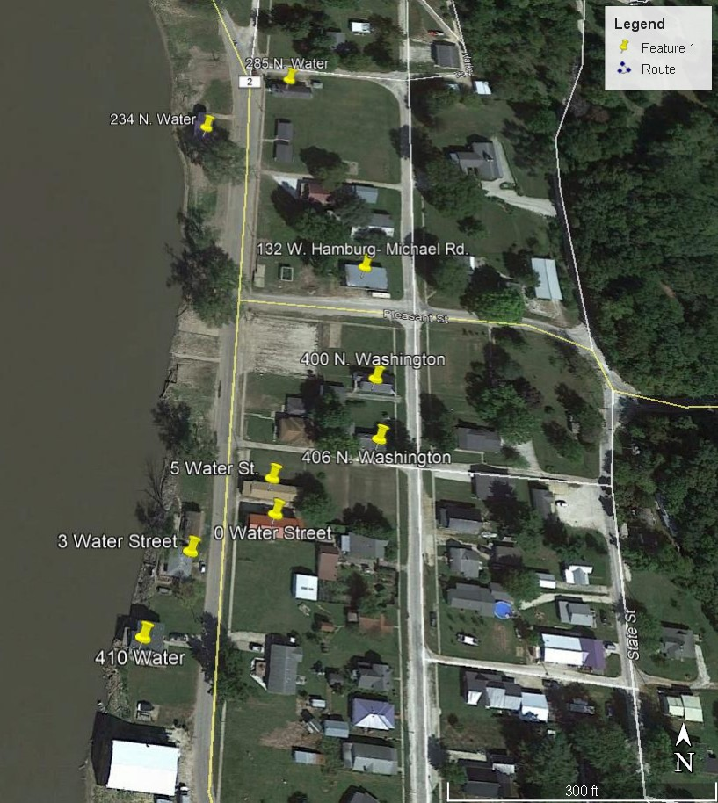
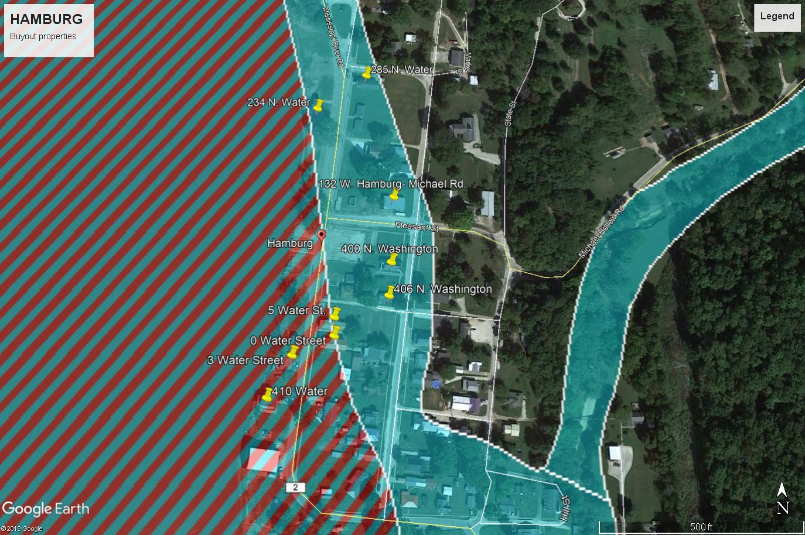

132 W Hamburg-Michael Road and 285 N. Water are included on these maps but are not included in the project. IHPA has questioned the acquisition of these properties, so we are proceeding with the acquisition of the other properties, while these two are appealed.

