December 17, 2021

Mr. Tim Anderson Mr. John W. Hollman
Secretary of the Senate Clerk of the House of Representatives
401 State Capitol Building 420 State Capitol Building
Springfield, IL 62706 Springfield, IL 62706

Dear Mr. Secretary and Mr. Clerk:

I am pleased to submit to the Illinois General Assembly the Public Library Capital Needs Assessment Report, as required by Public Act 96-37. The information in the attached comprehensive assessment report was compiled by the Illinois State Library from survey responses submitted by 647 public libraries from across Illinois.

Illinois’ public libraries welcomed the opportunity to respond to the Capital Needs Assessment Survey. The responding public libraries report a need for over $638 million of capital expenditures for new buildings, new additions to existing buildings and general repairs, which clearly indicates a great need for building improvements and repairs if our public libraries are to continue to be able to provide outstanding library services to the people of Illinois. I hope that this information will encourage the General Assembly to include public libraries in any future expansion of the State Capital Construction program.

Sincerely,
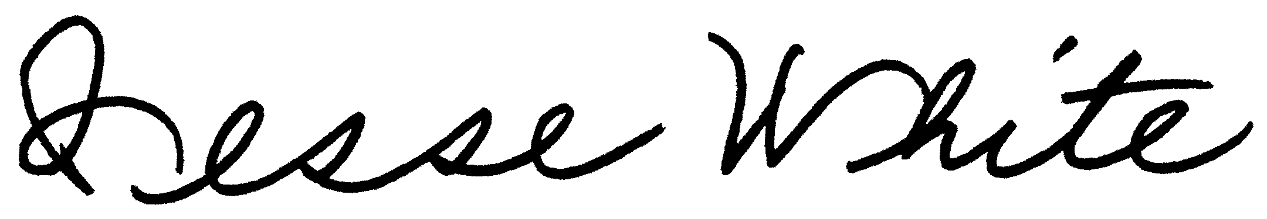
Jesse White
Secretary of State and State Librarian

cc: Senate President Don Harmon
Senate Minority Leader Dan McConchie
Speaker of the House Chris Welch
House Minority Leader Jim Durkin

