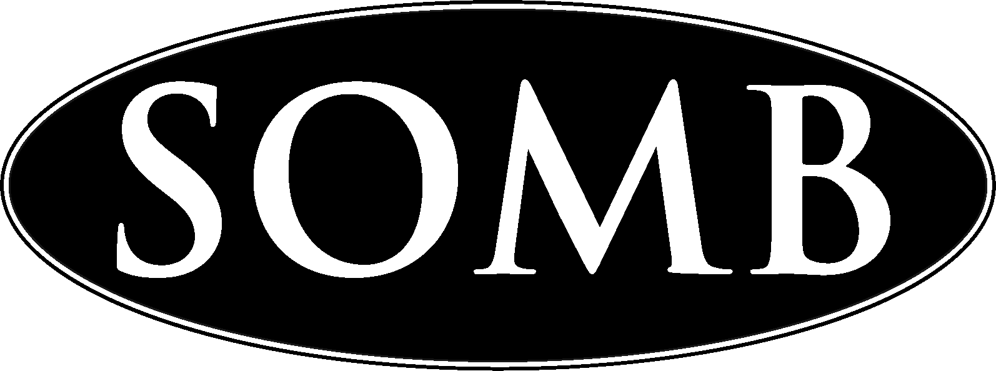

SEX OFFENDER MANAGEMENT BOARD

Per 20 ILCS 4026/20, the Illinois Sex Offender Management Board shall submit an annual report to the General Assembly regarding the training and educational programs developed and presented under this Act. The enclosed descriptions will detail the trainings that were provided during 2023 by the SOMB.

Static-99R and Stable-2007 training
Dates: March 15 and 16th, 2023
Time: 9:00 am – 4:30 pm
Location: Elgin, IL
Presenter/Trainer: Dr. Dawn Plufgradt, Psy.D.
Continuing education: 6 hours per day

Static 99R Description:
The Static- 99R is the most widely used actuarial risk assessment tool in the United States. The Static- 99R identifies the RISK part of the risk-needs-responsivity model of treatment need identification. Participants learned the most updated scoring rules for the Static 99-R and how to utilize Static 99-R conclusions to inform treatment and supervision.

Stable 2007 Description:
The STABLE-2007 is one of the most widely used risk assessment tools for measuring dynamic risk factors for sex offender recidivism. Participants learned about the development of the instrument, item-by-item instructions on how to reliably score the measures and interpret their findings, and guidance on incorporating STABLE-2007 results in written reports.

Working with Children and Adolescence with Sexual Behavior Problems (SBP)
Date: March 17, 2023
Time: 9:00am – 4:30pm
Location: IL ATSA
Presenter/Trainer: Keynotes: Dr. Amanda Pryor
Continuing education: 12 hours
Attendance: approximately 100 registered participants

Description:
Amanda Pryor, MSW, LCSW, CSAYC is a Licensed Clinical Social Worker with over eighteen years of experience. She is a graduate of Indiana University School of Social Work. Her specialty is working with children and adolescent’s with sexually problematic or harmful behaviors. She is the Director and is credentialed with Advocacy and Training Alliance. Amanda is also the Child and Adolescent Representative on the Association for the Treatment and Prevention of Sexual Abuse Board and an ATSA Fellow.

Submitted by: Sarah Brown-Foiles, Chairperson

