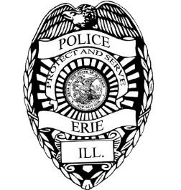

In 2019, the Erie Police Department was awarded two Watch Guard, squad car camera systems through the Illinois Law Enforcement Training and Standards Board reimbursement grant.

The installation of the two cameras was completed on July 19, 2019 with each video system installed in a separate squad car.

Once a month the Chief of Police downloads data from each camera and reviews the activity to ensure the officers adhere to department policies and state law.

Attached is a spreadsheet with the requested information pertaining to traffic stops which resulted in court proceedings.

